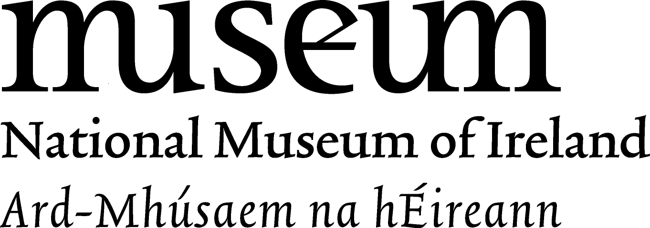
Treasury Trail
Bronze Horn, Loughnashade, Co. Armagh:
Q. Is there any decoration on the horn? Tick the answer
A. Tick the ‘Yes’ box
Q. Which musical instrument would you play loudly to frighten people? Write the name here
A. Any loud musical instrument could be put down here

Gold Boat, Broighter, Co. Derry:
Q. How many oars can you see on the boat?
A. 16
Q. Do you think a gold boat was a good gift for a sea god?
A. Yes, it was an excellent gift to the sea god. It was a high – status object and it meant that the people revered (looked up to/admired) the sea god. It was something that was extremely special and very important. The people who made this gold boat as an offering hoped the god would give the people help and protection on the rough seas when they sailed in their own boats.

The Ardagh Chalice, Ardagh, Co Limerick:
Q. Read the label and fill in the sentence below: The Ardagh Chalice was made 1200 years ago in the....
A. 8th Century AD

Q. Can you see the almost hidden initials of the apostles on the silver cup? Write one of them down here?
A. You may want to use the computerised interactive in the annex room of the Treasury exhibition to give you a close up view of the initials.

The Tara Brooch, Bettystown, Co. Meath:
Q. How many long – beaked birds are on the pin of the brooch?
A. 4
Q. How many eyes does the animal on the pin of the brooch have?
A. 8

The Shrine of St. Lachtin’s Arm, Donaghmore, Co. Cork:
Q. Can you see the snakes on the arm?
A. Yes

